Status Report 2

Current progress and expected progress

Sanjay Dookhoo

2017

# Project

UWI Alumni Network

# Date

02/08/2017

# Iteration

2

# Implementation Status

Besides the access of mongoDB for CRUD, A prototype interface was designed but scrapped. Therefore, nothing can be demonstrated as of yet.

# Highlights

Facebook API has removed the ability to retrieve a user’s phone number for security purposes (Such as unsolicited calls from hidden numbers). What Facebook API still has for contact purposes is:

1. Facebook messages (From an account, therefore an account must be made)
2. Mailing address retrieval

The mailing address and Facebook messages will be used for contacting purposes.

While as, LinkedIn will be used to retrieve important data that can be used to make analysis and provide a graphical illustration of the graduates.

# Risks or Issues List

|  |  |  |  |  |
| --- | --- | --- | --- | --- |
| Date Entered | Risk or Issue | Description | Resolution | Status |
| 02/02/2017 | Lack of test data | Test data will need to be created | - | Ongoing |
| 02/02/2017 | Reason for graduate students using this network instead of Facebook or LinkedIn | The popularity of Facebook and LinkedIn must be considered, the services provided cannot clash with what is already provided | - | Ongoing |
|  |  |  |  |  |

# Tasks in Progress or Completed in the Last iteration

PS “who worked on it” column removed since this is an individual project.

|  |  |  |
| --- | --- | --- |
| **Task Name** | **Description** | **% Complete** |
| Accessed data from mongoDB | Looked at a tutorial where I have confirmed that the frameworks Bottle and Pymongo was used to develop a demo application. | 100 (CRUD established with schema) |
| Confirmed direction of project | Confirmed direction of project | 100 (focus will be on data analysis and presentation) |
| Fixed use case | Fixed use case in the direction of project | 100 |
| Determine data necessary | Determined data necessary as seen in schema | 100 |
| Requirements established | Requirements established | 90 |

# Upcoming tasks for the Next Iteration

PS “who worked on it” column removed since this is an individual project.

|  |  |
| --- | --- |
| **Task Name** | **Description** |
| Create a small set of test data | Create a small set of test data |
|  |  |

# Established Database schema

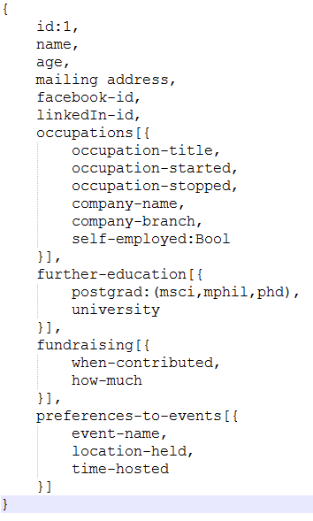

# User Stories

## From UWI Staff

1. After students, have left the university, the staff has no way of ensuring the student can be contacted. This is because phone numbers can be changed due to switching to another provider, moving to another country, losing one’s phone, etc.

(Solution: A Facebook account is almost permanent with respect to a person because of the history that is recorded of them that they do not wish to discard. It can be assumed that Facebook messaging is a solution, therefore Facebook login is required)

1. The university is responsible for providing a sound education as well as the means to sell oneself to possible employers. Yet still, in Trinidad and Tobago, where GATE funding is so readily available, the employment demands and graduate students may be growing further apart. Under-employment is more likely than unemployment, which would be good to keep track of.

Determine an approximate level of under-employment in Trinidad as well as effects of brain drain, where graduate students leave for better job opportunities (Possible Solution: Looking into the levels of company page viewing on LinkedIn despite being employed, unsure if this data can be accessed by the API provided)

1. Similarly, the length of time a graduate student is unemployed after graduation can be relevant
2. How frequent a graduate student changes their profession status may be a sign of rising instability in that sector. Rising popular professions may be a sign of shifting focus in another sector/economy.
3. While as, profession changes within the corporation itself may be a sign of still potential growth.
4. Determining the most popular trends in a particular degree based on which profession subset is mostly pursued. Example, in Computer Science, the majority of students may be employed in application development for 2017 onwards while as starting from 2020 there may be a focus on Data mining.
5. Those who would like to start a company on their own where they are self-employed are unable to for several reasons. If the company can satisfy some future needs of the university, UWI may very well be interested in investing in their students for greater future benefits.
6. The average potential salary of prospective students can also be determined, potentially, though this may be a breach of NDA and there is no particular way of amassing average salary pays in Trinidad compared to foreign countries.

## From graduates and current students

1. Students current job and specified preferences may help narrow the notices and events that the university would like to inform their graduate students. It helps filter what is not important from what is important. Preventing the graduate student from simply ignoring all notices since the majority of notices tend to be irrelevant
2. While as the graduate students are grateful for the education they were given, once they have entered the working world with a stable job, the university’s events may no longer be relevant to them. Tailored courses and events can be made for such persons as attempts at fundraisers.